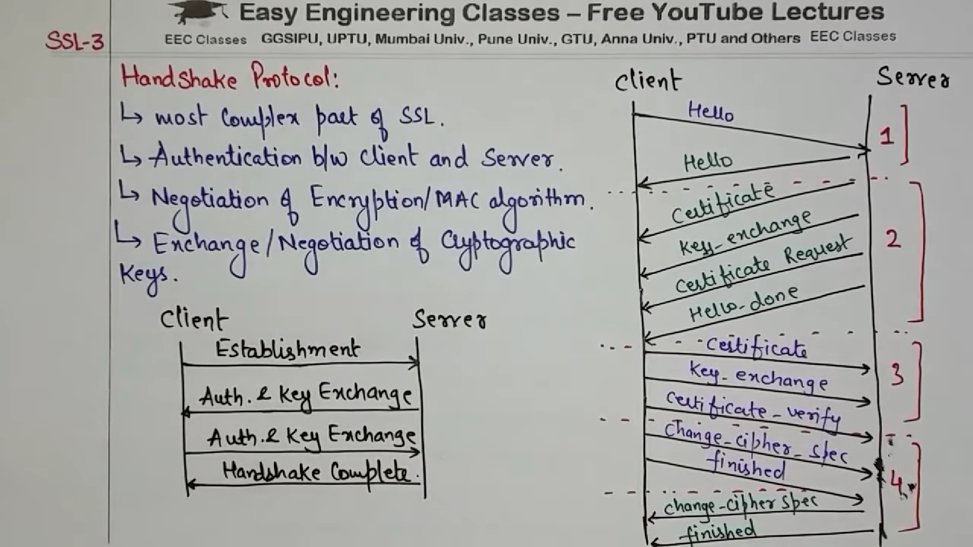

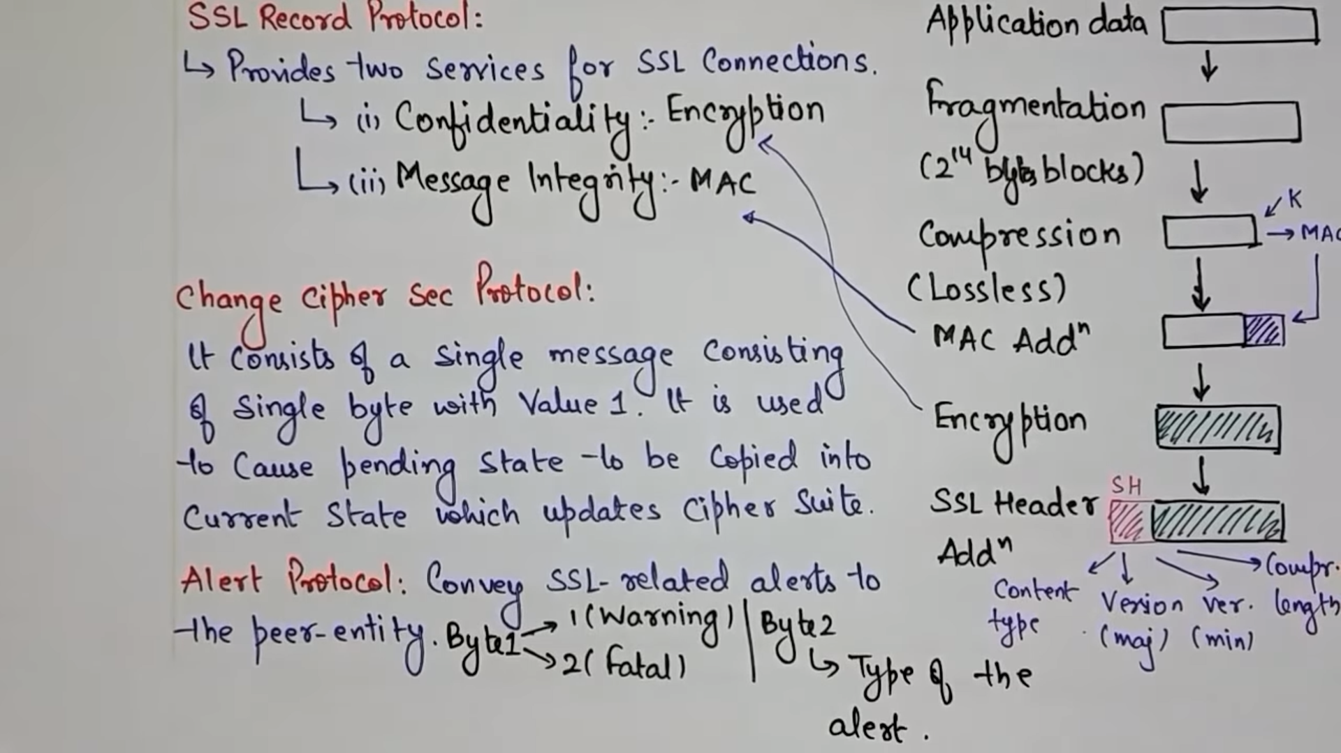

Jun cipher sec protocol xani tesko kaam vneko store the information about ssl handshake terminates or not ho

Ani alert protocol ma chai 2 wota bytes use hunxa euta byte le error display grxa tyo error warning ni huna skxa fatal error ni huna skxa ani byte 2 le type of alert kun ho specify grxa